Welcome to Cornerstone!

First time Visitors
We are glad you are here! Please take a minute to fill out the white card you found on your seat and turn into our Welcome Center after the service
for a gift.

Cornerstone Kids
Infants – 5th Grade: Nursery is available downstairs. Cornerstone Kids for K-5th is dismissed from the service.

Bibles
If you don’t have a Bible please take one from the back table and take it home with you.

Our Vision
A gospel-centered church that changes lives through sharing the message of Jesus Christ in word and deed

Our Mission
To make, mature, and multiply followers of Jesus

Social Media Prayer Network
Check us out on Facebook Do you have a prayer request? Cornerstone Congregational Church Fill out the white card, or email
Westford, MA prayer@cornerstonewestford.com
CornerstoneWestford@gmail.com
978- 692-6360
32 Graniteville Road, Westford, MA 01886
www.cornerstonewestford.com

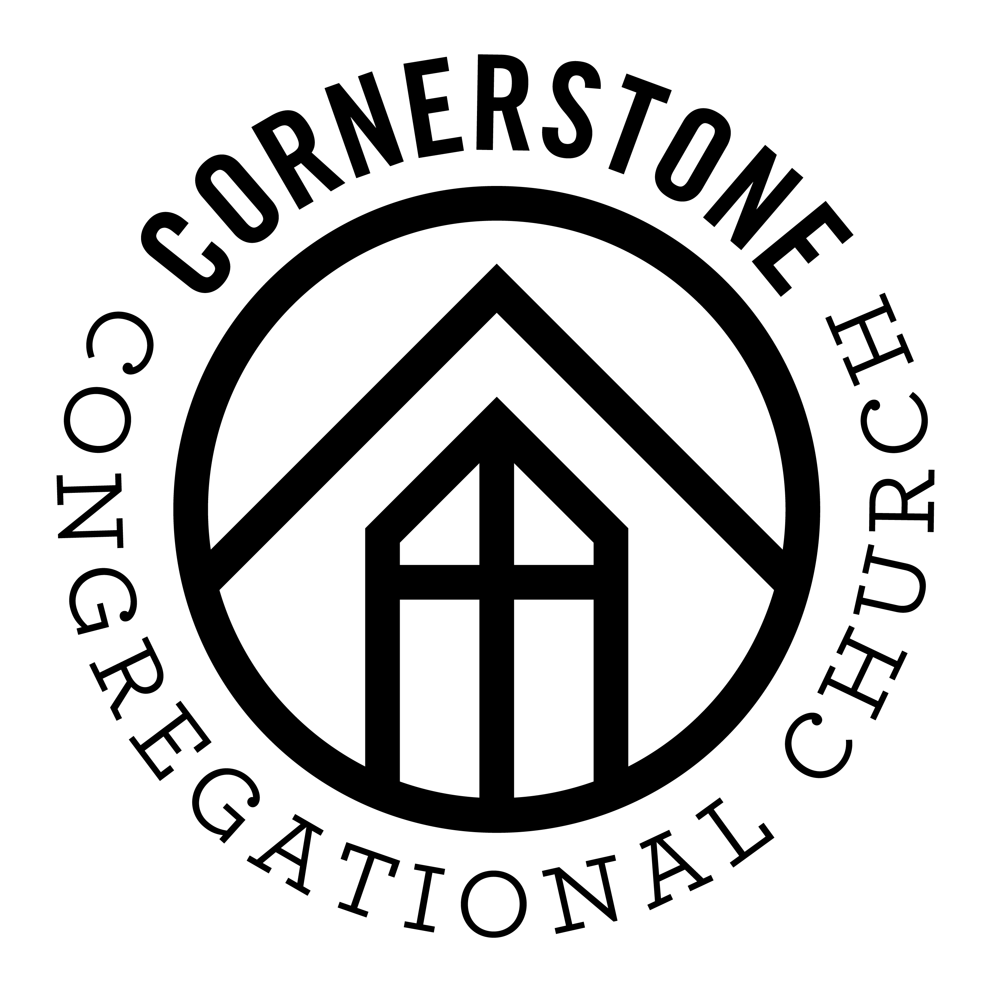
Core Values
Bible - We study, preach, apply and share God’s Word.
2 Timothy 3:16-17

Community – We gather together to worship God and welcome new friends.
Acts 2:42-47

Discipleship – We learn to love and obey Jesus to help others do the same.
Matthew 28:18-20

Love – We receive and share God’s love and grace because Jesus first loved us.
John 13:34-35

Outreach – We serve others and share the gospel.
Jeremiah 29:7; Acts 1:8

Prayer - We invite God to work in our lives, church, and town. Romans 8:26

Jonathan Romig, Pastor
Saturday, May 26, 2018

Saturday, September 10, 2016

