Ephesians 2:8-10

For it is by grace you have been saved, through faith -and this is not from yourselves, it is the gift of God - 9 not by works, so that no one can boast. 10 For we are God’s handiwork, created in Christ Jesus to do good works, which God prepared in advance for us to do. (NIV®)

**Welcome to Cornerstone!**

**First time Visitors**

We are glad you are here! Please take a minute to fill out the white card you found on your seat and turn into our Welcome Center after the service

for a gift.

**Cornerstone Kids**

Infants – 5th Grade: Nursery is available downstairs. Cornerstone Kids for K-5th is dismissed from the service.

**Bibles**

If you don’t have a Bible please take one from the back table and take it home with you.

**Our Vision**

A gospel-centered church that changes lives through sharing the message of Jesus Christ in **word** and **deed**

**Our Mission**

To **make**, **mature**, and **multiply** followers of Jesus

**Social Media Prayer Network**

Check us out on Facebook Do you have a prayer request? **Cornerstone Congregational Church** Fill out the white card, or email

**Westford, MA** **prayer@cornerstonewestford.com**

**CornerstoneWestford@gmail.com**

**978-692-6360**

**32 Graniteville Road, Westford, MA 01886**

**www.cornerstonewestford.com**

**Core Values**

**Bible** - We study, preach, apply and share God’s Word.

**2 Timothy 3:16-17**

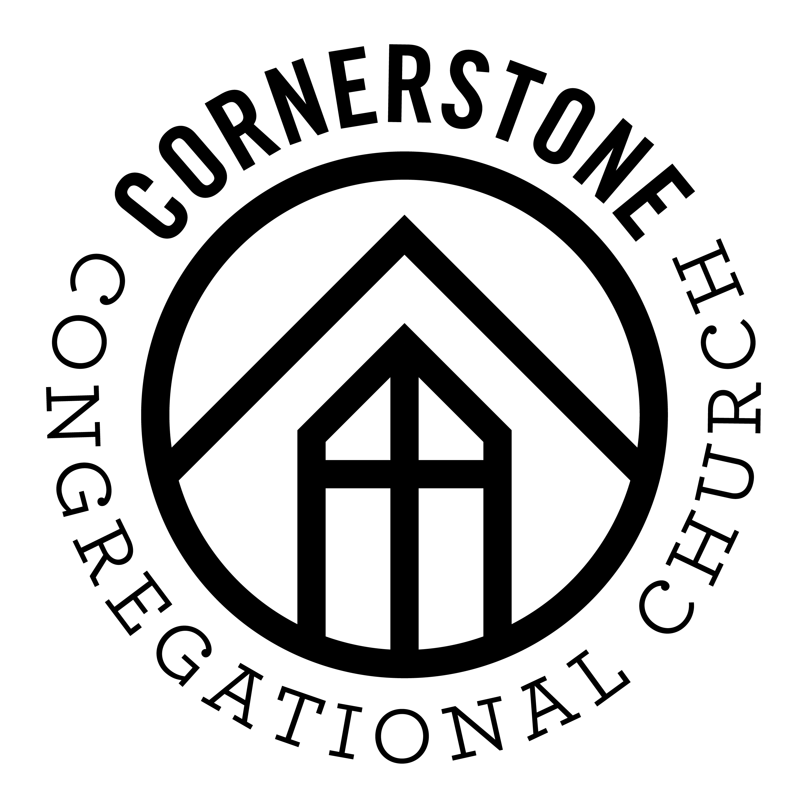**Community –** We gather together to worship God and welcome new friends.

**Acts 2:42-47**

**Discipleship –** We learn to love and obey Jesus to help others do the same.

**Matthew 28:18-20**

**Love –** We receive and share God’s love and grace because Jesus first loved us.

**John 13:34-35**

**Outreach** – We serve others and share the gospel.

**Jeremiah 29:7**; **Acts 1:8**

**Prayer** - We invite God to work in our lives, church, and town. **Romans 8:26**

**Jonathan Romig, Pastor**

**Saturday, September 15, 2018**

Saturday, September 10, 2016